- Cho lược đồ quan hệ LOTS(PROPERTY_ID#, COUNTY_Name,LOT#, AREA) and two functional dependences
Fd1: property_id# →{COUNTY_NAME, LOT#, AREA}
Fd2:{COUNTY_NAME, LOT#}→{PROPERTY_TD#, AREA}
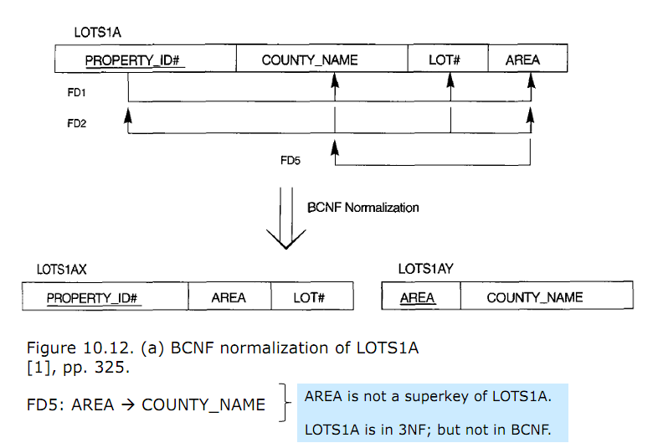
Then LOTS is in BCNF
True/fales?

- Phân biệt giữa các phép trong Đại số quan hệ
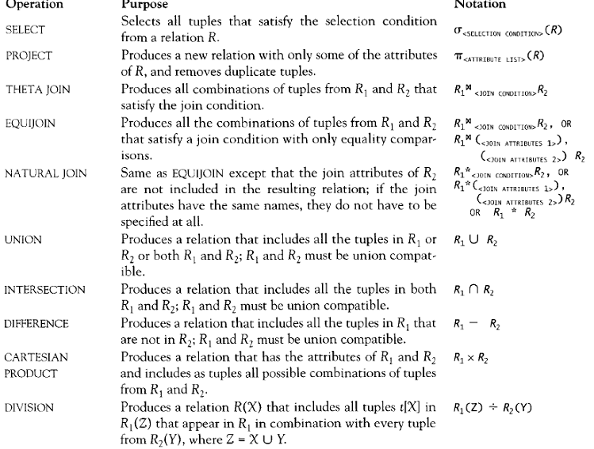

- Which of the following are not functions of a DBA?
- Security and authorization
- Transaction managemnet
- Database design
- Performance monitoring
- Back up

